⭐ 1 - Project Overview

Codebase Q&A Task Workflow
`

What Is Codebase Q&A?
Our Mission: Building the dataset that teaches AI agents to reason about real codebases.
Codebase Q&A is a reinforcement learning environment for training AI agents to explore and to reason about software repositories with which they are not previously familiar. You will be on a talented team contributing to the most advanced AI frontier models, with the goal of significantly pushing the boundaries of AI's current capabilities by learning its failure points.

In this project, you will help build a rigorous dataset of difficult codebase-exploration tasks, which will be used to train and to evaluate an AI agent's ability to answer high-level engineering questions about open source codebases - questions that require runtime evidence - the kinds of questions that an engineer might ask their team lead while onboarding on day one of a new project.

The quality of your contributions is of enormous importance, as this project may be extended into a multi-month engagement if we deliver on time and at a high level of quality. Your excellence will help lead to more work for all of us! (Refer onboarding call here).

Inputs

For each, you will choose from a varied list of pre-validated tasks, spanning many repositories and multiple coding languages. A task for Codebase Q&A will consist of:

- A codebase, pinned to a specific git commit
- An engineering question relevant to that codebase at the given commit
- Positive and negative rubrics, to measure the success of the agents in solving the question
- Foils, to measure various ways in which the agents may produce plausible, but incorrect, solutions
- A "golden solution" that solves the problem correctly, passing all rubrics and avoiding all foils
- Proof artifacts, to verify that the solution is both difficult to solve, and fair to the agents (i.e. they are well-defined and can potentially be solved by a sufficiently capable agent)

You will see more details about what these entail as your progress through this document and through the screen shots and sample downloads that we provide.

What Will I Do?
Once you have selected a task, the workflow for Codebase Q&A is as follows:

- Download the zip file containing the task's seed files
- Explore the repository. You should familiarize yourself with the code, the PR that fixes the issue (if available), and the specific code sections in question. Here is one of the few places where you are allowed to use LLMs to explore (and only to explore) the code's existing functionality.
This will begin with one of two paths:
  - For private repositories, they are included in the zipfile
  - For public repositories, check them out from github and apply the given commit
- Read the Question, the rubrics, and the foils to understand what problem the agents are being asked to solve

Now comes the work/revision loop. You will iterate on this loop until the problem is solved or until its difficulty level is proven too easy. Each iteration will look like this:

- Rewrite the task's Question
- Adjust the rubrics and (less commonly) the foils as needed to account for the modifications to the Question
- Upload the zipped Task to Studio
- Run Check
- If Check succeeds (turns green), run the Golden step
- If Golden succeeds, execute the Run step
- If Run succeeds, execute the Analyze step

At any point, if a step fails (turns red), check the output of the step and adjust accordingly, then start again at step 3 with the upload with your fixes. Once every step is green, update your README.md and you're ready to submit the Task to QA.

How Does It Work?

You will work within Mercor Studio. In essence, Studio provides you with every tool you'll need to develop your Tasks, including the LLM tools that you'll be exercising. It is here that you will choose your Tasks, run the analyses, view the output, and go through the workflow of submitting your tasks to QC and then responding to QC reviewer feedback as needed.

Within Studio, you will see a dropdown in the left panel for the Tasks which are available within this project's world:
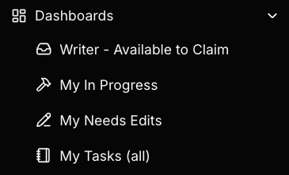

Clicking on this will take you to the list of Tasks, with an option to filter the list in varied ways (click the Filter button to explore these on your own).

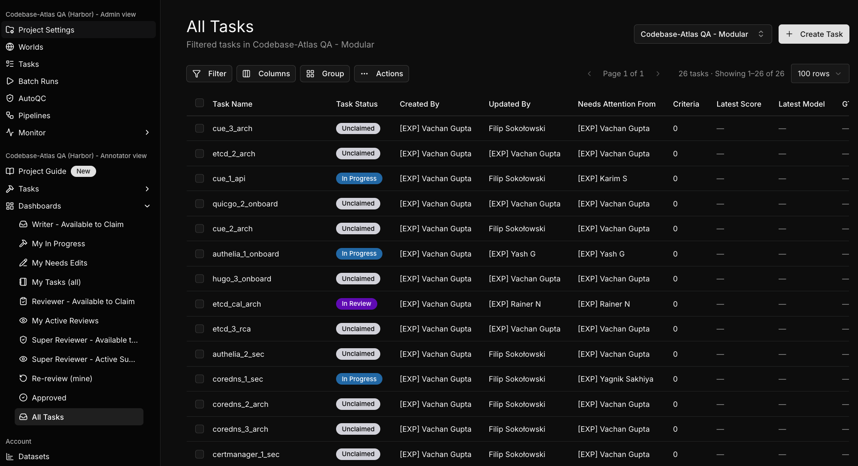

You will also see a Dashboard in the left panel that has a few entries that you can click to see your own claimed Tasks, as well as those available to you. Feel free again to explore these on your own.

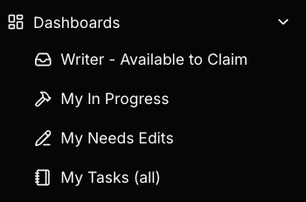

From the list of tasks, select one and download the Task's zip file under the Task Package dropdown:

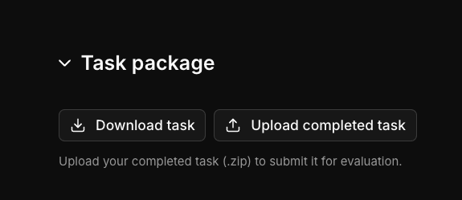

Now you can explore the task to see if it's one that suits your particular skills and language expertise - more on that in a bit, but the files to inspect initially are:
- README.md, which contains the information about the task - repository/commit/issue (if the code is public - if it is private, the code will be contained in environment/source.tar.gz), the language, the difficulty, and what a correct answer requires.
- instruction.md, which has the question you'll be refining to stump the agents.
Once you find a task that you're comfortable working on, claim it using the button near the bottom in Studio, under Actions:

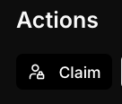

Once you've started working by modifying the Question (in instruction.md) and the rubrics (more on that shortly), you'll do a set of agent runs. Each run will only make sense after the previous one succeeds. Here's an overview of what they entail:

- Check - a basic check of the zip file you've uploaded, to make sure that everything's in the right places and can be read by Studio to achieve the goals we're working toward.
- Golden - a cutting-edge agent run that will solve the problem 100%, passing all rubrics and avoiding all foils. The Golden output, which you'll be harvesting after it succeeds and including in your uploads, is what we'll use to compare to the other runs which we aim to have fail.
- Run - the agents that we're trying to stump. In this case, Kimi should always fail (a Question that Kimi has pretty good success at is considered too easy), and we aim to have the other agents fail at least in some significant measure.
- Analyze - this gathers the metrics that we'll use to determine if the Run step has produced success in our goal of stumping the agents in the ways that we're looking for.

What Is The Goal?

The primary goal here is to make tasks which are difficult enough to fail on frontier models. Using failures of Kimi, a less advanced model, as a baseline level of difficulty, we then measure our other agents to see if they can also be stumped - it is these agents which we're helping to refine and to grow as we push their frontier capabilities outward.

The agent and version currently in use as of August 18, 2026 are Kimi 2.6 - and the (single, at this time) frontier model:

- Gemini 3.6 Flash

🌐 2 - Account access

🔐 1 Account Access (Okta + Slack + Email)Which Email Goes Where
Platform | Email to Use
work.mercor.com | Personal email
Okta | Personal email
Insightful | Personal email
@mercor.expert Google Workspace | Accessed through Okta (not used to log into Okta)
The @mercor.expert contractor email cannot be used to access Okta.
Okta and Passkey Setup
Access is granted through your contract; you will not receive a separate email invitation. Okta single sign-on covers Slack, RL Studio, and Google Workspace. Set up your passkey in Google Chrome, logged into your personal Gmail with sync on, using Google Password Manager. Do not use incognito.
Use Google Chrome. Firefox is not supported because it does not support the Okta WebAuthn configuration used for the passkey.

Slack through Okta
Your Slack access is provisioned through Okta, so there is no separate Slack invite. Slack may take up to 24 hours to synchronize after you complete the Okta setup. Slack usernames are auto-prefixed with [EXP].

Email Migration Note
If you were issued a @c-mercor.com address, it deprecates after a transition period (with at least one week of notice); you keep both addresses during the transition.

🕔 3 - Time Tracking

⏱️ 2 Time Tracking with Insightful

Getting the App
You will receive your Insightful invitation from support@insightful.io, usually within 48 hours. If it does not arrive, download the app directly from the Insightful download page. The desktop app is called Workpuls.

Supported Operating Systems
OS | Version
Windows | 10 or later (.NET 4.8 or later)
macOS | 11 Big Sur or later (macOS 12 recommended)
Linux | Ubuntu/Mint 20.04+ or Fedora 32+ (Beta)
Chromebooks, iPads, phones | Not supported

Three Rules
- One device: Only one device may be clocked in at a time. Offline or airplane-mode hours do not sync.
- Internet required: You must be online for time to sync.
- Email match: Always sign in with the personal email on your Mercor profile.

Common Errors
Error | Resolution
"User not found" or "Create organization" prompt | Usually means your login email changed. Do not create a new organization; sign in with the personal email on your Mercor profile.
400 error | Usually means your account is still being created. Wait and try again.
Invitation link expired | Invitation links expire after 48 hours. Use the direct download link if yours has expired.

✅ 4 - Onboarding Checklist

3 Onboarding Checklist

Pre-Acceptance
- Create your Okta account.
- Verify your identity with Persona (government ID plus selfie).
- Complete your background check. Most checks are completed within 3–7 days (run via Certn or Zinc). You cannot begin work until your background check clears.
- Sign the Terms of Work.
- Sign the CIIAA (this protects the client's IP).
- Complete your tax form (W-9 if a US person, otherwise W-8BEN).

Acceptance
- Sign your offer letter.
- Set up payments (Stripe is primary, Wise is the fallback where Stripe is unavailable).

Post-Acceptance
- Join Slack through Okta.
- Install and connect Insightful (required on this project for all roles).
- Pass the calibration quiz. You must score above 10 and above (you get 2 attempts) before Slack and RL Studio access are provisioned. Turn Insightful OFF while you take the quiz.
Quiz link.
- Get access to Slack and the project tool (RL Studio), granted once you pass the calibration quiz. (Please login into the alternate world: Modular world in RL studio and not the old codebase QnA world).

You Are Fully Onboarded When:
Your Okta account is active, your identity is verified, your background check has cleared, your Terms of Work, CIIAA, and tax form are signed, your payments are set up, you are in the project Slack channel, and you can open a task in RL Studio.

🆘 5 - Support and Escalation

4 Support & EscalationPoints of Contact
Role | Name | Contact
POC / Project Owner | Rick Lacerda | ricklacerda@mercor.com
Expert Team Leads (day-to-day) | East Coast time:  [EXP] Heath D  Nigeria time:  [EXP] Rainer N  India time:  [EXP] Vachan Gupta  [EXP] Niharika M | In project Slack channel
Offboarding Requests | Arya Paryani | aryaparyani@mercor.com
General Platform Support | Mercor Support | Help option in work.mercor.com

Slack Channels
- #codebase-qna-announcements — updates and general announcements
- codebase-qna-reviewers – channel for reviewers

Escalation Order
- Search this guide and the project Slack channel for an existing answer.
- Ask in the project Slack channel.
- Direct-message your team lead if it is blocking and unanswered.
- Ask your lead to escalate to engineering for platform or task-data issues.
- Contact Mercor platform support for account, access, or payment issues.
Response time: We aim to respond in Slack promptly during working hours. Expect a reply from your leads within one business day.

🛠️ 6 - Annotator Workflow

⭐ 6 Annotator workflow

Studio
Studio runs mini-swe-agent, an open source harness that runs AI agents. For the most part, you don't have to know much about it, but the important bit is that it does run the codebase - our entire project is based on the idea that the issues are ones that can only be found and exercised by running the code.

Choosing a Task

One of the keys to working on your Tasks is to familiarize yourself with the codebase and what the pieces of the code which are relevant to the Question are doing. You'll be given plenty of information about the problem the Question is trying to solve, including:

- The initial Question (contained within instruction.md) - this is one you'll be refining to make the problem difficult
- The codebase, including the repository and the commit upon which you'll be working (contained within README.md)
- The issue description (also contained within README.md)
  - In some cases, the PR containing the real-world fix will be accessible on GitHub, from the issue link - this can also be useful in your approach, both in terms of seeing what one fix for the code can be,

The most important thing to consider is your familiarity with the language, as well as the type of software the Task addresses. Tasks span a wide variety of languages and Task definitions, so don't worry if one specific Task that you look at is unfamiliar - maybe it's a front-end task when you're largely a middle-tier developer, or it's a database migration tool that you've never worked with before. Just look at another Task instead!

Task definitions:
- Architecture & System Design
- Root-Case Analysis
- Code Onboarding
- Security
- API & Library Integration
It can also help to choose Tasks that happen to be in open-source projects that you've used before. Many of our Tasks involve working on widely-known projects such as Pandas, FastAPI, Vue.js, Quarkus, and WebPack - if you've used the software before, coming up to speed on its codebase will be that much easier!

Definitions

Before we start exploring a sample Task, let's define some terms.

- Task - the zip file with the Question, the repository/commit/issue information (public or private), the foils and rubrics for the initial Question, and other files which tell Studio how to run and to evaluate the agents' performance
- Question - the instruction that you're asking the agents to perform - a bug fix, an enhancement, etc. This is where you'll be doing the majority of your work, tweaking the Question until you either meet the requirements or you deem the task too easy for our project.
- Oracle - a known-good path, comprising a Question, solution script, answer, and trajectory file
- Verifier - the test results which scores the results using RewardKit
- Rubrics - the success criteria against which an agent's performance is measured. This includes both positive (the agent successfully met a requirement) and negative (the agent did not fall into a trap - a false positive or the like) rubrics.
- Foils - plausible wrong answers that the agent might generate; each is connected to at least one of the rubrics that it must fail
- Golden Solution - the fully successful run (reward = 1.0), with the answer the agent gave, as well as its trajectory data
- Reward - the score from an agent's run. 1.0 is a perfect score, and meant the agent met every rubric fully.

Anatomy of a Task

Here's a basic overview of a Task's zip file (this is for a public repository, a private one will also contain the repo contents as well).

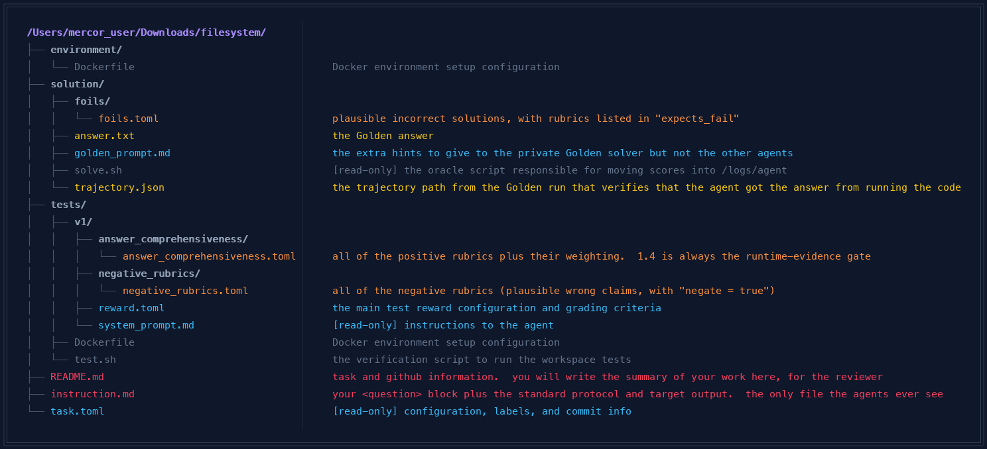

Now let's walk through a real example.

Understanding a Task

Let's walk through a sample Task. Start with a look at README.md. The first lines to look at are "Target repo", "Pinned commit" and "Issue".

# pytest Codebase Q&A

Task type: codebase_qa
Target repo: pytest-dev/pytest
Pinned commit: cf470ec0bf7eb89cd97dd56df4859eae5db46447
Category: Root-Cause Analysis
Language: python
Difficulty: hard

## Source

- Issue: [pytest-dev/pytest#10844](https://github.com/pytest-dev/pytest/issues/10844)
- Title: Pytest assert rewrite fails when rewriting some parts of cassandra cython code
- Labels: type: bug, topic: rewrite
- Grounding pack: [`grounding/pytest-dev-pytest-issue-10844.md`](../../grounding/pytest-dev-pytest-issue-10844.md)

## Summary

A plain, non-test Python module transitively imported during collection (in the original
report, a Cython-adjacent constants file from a third-party dependency) starts raising a
`KeyError` for a name that never appears in its own source, but only when it is imported
through pytest's assertion-rewrite import hook -- never via a plain `import`. The module
contains zero `assert` statements. The root cause lives entirely in pytest's own assertion
rewriter: `AssertionRewriteHook.find_spec`/`_should_rewrite` decide whether to rewrite a
module purely by matching its file name/path against configured patterns (or explicit
`pytest_plugins`/`register_assert_rewrite` registration) -- never by scanning the source for
the word "assert" -- and `AssertionRewriter.run()` unconditionally splices two specially
named imports into the module's AST *before* it ever searches for actual `assert` nodes to
transform. Because `exec_module()` executes the rewritten code with
`exec(co, module.__dict__)`, those two names become permanent, ordinary entries of the
module's own namespace, visible to any code that later introspects that module's attributes
(such as a generator expression iterating over `vars()` of the module).

## Evidence Plan

- Load-bearing file: `src/_pytest/assertion/rewrite.py` (`AssertionRewriteHook.find_spec`,
`_should_rewrite`, `_early_rewrite_bailout`, `AssertionRewriter.run`, `exec_module`).
- Distractor: the assert-rewriting visitor logic itself (`visit_Assert` and its
helper/explanation-formatting methods), which is never reached for a module with zero
`ast.Assert` nodes and is not where the reported defect lives.
- Evidence tokens: the two specially-named imports spliced into every rewritten module's AST,
the pattern/name-based (not content-based) rewrite-selection decision, and the fact the
rewritten code executes directly into the target module's own `__dict__`.
- Runtime evidence: importing a zero-assert scratch module through pytest's collection (with
assertion rewriting enabled vs. `--assert=plain`, and vs. a plain `python -c` import outside
pytest entirely) and inspecting the resulting module namespace to show the injected names
are present only in the pytest-rewritten case.

## Difficulty and failure modes

The near-miss is assuming pytest's assertion-rewrite machinery only ever touches files that
actually contain assert statements, or that any bug here must live inside the logic that
rewrites an assert's own generated explanation code. Both are false: the module-selection
decision is purely name/path based, and the special-import injection happens before any
assert-searching occurs at all, so a module with zero asserts can still be rewritten -- and
have its namespace altered -- purely because its path matched a test-file pattern or it was
pulled in by an explicit plugin registration. The foils in `solution/foils/foils.toml` embody
this near-miss, plus a wrong-boundary claim that rewriting requires already-detected asserts,
and a hallucinated cleanup step that would (if real) have already prevented the leak.

The combination of:
- the repo (pytest-dev/pytest)
- the commit (cf470ec0bf7eb89cd97dd56df4859eae5db46447)
- and the issue (https://github.com/pytest-dev/pytest/issues/10844)

allows you to check out the code locally, or to view them in a browser on github.

Now read the Summary section to understand the problem that the agents will be trying to solve. Going to the issue's page to read some of the comments may help. In this case, the issue is still open (as of August 17, 2026), but if the issue has been fixed, you may also get some good information by reading the PR that contained the fix.

The issue will often also give you data about where the crash trace (or incorrect behavior) is and what it looks like in practice - key data when results exclusively from running the code is the focus of our work.

Scan the Difficulty and failure mode section, then check out (briefly) the Evidence Plan - these won't make much difference in your day to day work, but it's good to see what's in them.

Throughout all of this, take notes to organize your thoughts, and check out the difficulty requirement, which will give you a hint at what kinds of failure scores we need for this (more on scoring requirements later).

Review the Question

Now let's look at instruction.md. This is one of the main files that you will be editing. Inside the <question> tag is where you'll be refining the Question for the agents. The instructions above and below will stay the same.

<uploaded_files>
/app
</uploaded_files>
I've uploaded a code repository in the directory /app. Consider the following question:

<question>
In a large test suite, we widened the glob pytest uses to decide which `.py` files count as test files, mostly so we'd stop accidentally skipping some real test modules. Ever since, one specific plain Python module that gets pulled in transitively during collection -- it has no test functions and, as far as I can tell from reading it, not a single `assert` statement anywhere in it -- started raising a `KeyError` for a name that doesn't correspond to anything a person actually wrote in that file. It only happens when the module is imported as part of a pytest run; importing the exact same file outside of pytest never reproduces it. The failure surfaces a couple of frames down, inside a generator expression that iterates over that module's own attributes. Disabling pytest's assertion-rewriting machinery for just that one file makes the problem vanish completely, which is the only lead I have. I don't understand why a module with zero asserts in it would ever be touched by that machinery in the first place, let alone end up with something extra sitting in its own namespace as a result. Can you work out exactly what pytest does to a module before it decides whether there's anything worth rewriting in it, and confirm what actually ends up living in such a module's namespace once pytest has processed it, with file:line citations plus runtime evidence?
</question>

Can you help me answer this question about the codebase?
Your task is to analyze and explore the codebase in /app to find the answer. Do NOT modify any files in the repository.
Follow these steps to answer the question:

1. Explore the repository structure to understand how the codebase is organized
2. Find and read code relevant to the question
3. Run scripts or trace code paths to gather evidence for your answer, and include at least one command you ran with its verbatim output
4. Synthesize your findings into a clear, well-supported answer
5. When you are confident in your answer, write your complete final answer to /logs/agent/answer.txt wrapped in <<FINAL_ANSWER>> tags. Do not only print the answer in chat output; the answer file is required for scoring. Use this exact format:

```bash
mkdir -p /logs/agent
cat <<'ANSWER_EOF' > /logs/agent/answer.txt
<<FINAL_ANSWER>>
Your comprehensive answer here, including all relevant findings, code references, and explanations.
<<FINAL_ANSWER>>
ANSWER_EOF
```

We want to consider a few things here. First, is the difficulty of the Task nontrivial? The answer must always require real investigation, including runtime results as part of the analysis.

Here are a few good ways of telling whether or not the Task is trivial:

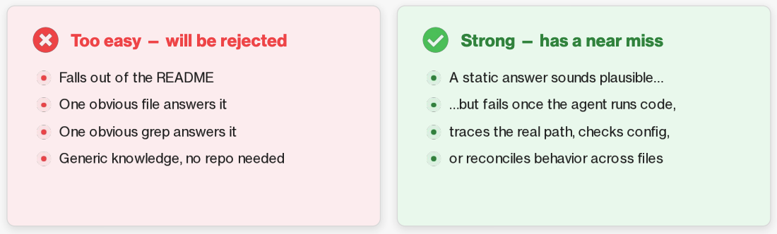

Another consideration is whether or not the Task is "leaky". A leaky instruction is one that has a giveaway to the agent, for example a pointer to the file or the line in the code where the problem exists, or some constant or method/function name that turns the task from an investigative one into a simple grep or similarly trivial operation.

The Question should be written in a real human-language fashion - the way that you'd be asking a developer to look into it - either in a written sense or even conversationally.

Positive Rubrics
Now to check out the rubrics. First, you can see here the list of positive tests that the agents must pass to be given credit, as well as their relative weights. The Golden run, of course, will have passed on all of these.

tests/v1/answer_comprehensiveness/answer_comprehensiveness.toml
[judge]
mode = "batched"
atif-trajectory = "/logs/agent/trajectory.json"
files = ["/logs/agent/answer.txt"]
cwd = "/"
prompt_template = "../system_prompt.md"

[scoring]
aggregation = "all_pass"

[[criterion]]
id = "1.1"
name = "unconditional_import_injection"
type = "binary"
weight = 3.0
description = """
The answer must identify that `AssertionRewriter.run()` in
`src/_pytest/assertion/rewrite.py` (around lines 715-728) inserts two special
imports -- an aliased import of `builtins` and an aliased import of
`_pytest.assertion.rewrite` -- into the target module's AST unconditionally,
before it ever walks the module body looking for actual `assert` statements
to rewrite. PASS if the answer states that these special imports are added
regardless of whether the module contains any assert statement at all; FAIL
if it claims the imports are only added when an assert statement is found or
rewritten.
"""

[[criterion]]
id = "1.2"
name = "rewrite_decision_is_pattern_based"
type = "binary"
weight = 3.0
description = """
The answer must explain that pytest decides WHETHER to rewrite a module by
matching its file name/path against configured collection patterns (or via
explicit registration such as `pytest_plugins`/`register_assert_rewrite`) in
the assertion-rewrite import hook (`AssertionRewriteHook.find_spec` /
`_should_rewrite` / `_early_rewrite_bailout` in
`src/_pytest/assertion/rewrite.py`), and never by scanning the module's
source text for the presence of the word "assert". PASS if the answer
connects a broadened test-file pattern (or an explicit plugin import) to a
previously-untouched, assert-free module now being eligible for rewriting;
FAIL if it does not address how the rewrite-or-not decision is made.
"""

[[criterion]]
id = "1.3"
name = "injected_names_persist_in_module_globals"
type = "binary"
weight = 2.0
description = """
The answer must explain that the rewritten code is executed with
`exec(co, module.__dict__)` in `exec_module()` (around line 188 of
`src/_pytest/assertion/rewrite.py`), so the two injected names become
permanent entries of that module's own `__dict__`/globals for the lifetime of
the module object, not transient locals scoped to some helper function. PASS
if the answer states that these names remain visible to code that later
introspects the module's own attributes/globals (e.g. iterating over
`vars()`/`dir()`/the module dict); FAIL if it claims the injected names are
temporary, local-only, or removed once rewriting/compilation finishes.
"""

[[criterion]]
id = "1.4"
name = "runtime_evidence"
type = "binary"
weight = 1.0
description = """
The answer must be confirmed by observed runtime evidence -- at least one command
the agent actually executed, shown with its verbatim output -- not by reading
source alone. This is a baseline requirement of the Codebase Q&A design: the
conclusion must be grounded in something that was run (a probe, a focused test, a
script, or a git / inspection command), with the produced output present in the
answer.

PASS if the answer includes at least one executed command together with its
verbatim output and uses that output to support its conclusion.
FAIL if the answer is pure code reading or static description with no executed
command output.
"""

[[criterion]]
id = "1.5"
name = "unfilterable_special_names"
type = "binary"
weight = 1.0
description = """
The answer must note that the injected names use an `@`-prefixed spelling
that cannot appear in ordinary Python source (since `@` is not a legal
identifier character), but that this only prevents accidental collisions with
names a person could type -- once the module has executed, these are
ordinary string keys in the module's namespace and are not automatically
excluded by common "public API" introspection filters such as a
leading-underscore check. PASS if the answer makes this distinction (unwritable
as source vs. ordinary and visible at runtime); FAIL if it does not address why
such names would not simply be filtered out by typical introspection code.
"""

Please note that criterion 1.4 will be the same in every single Task. Do not ever modify it - it is the criterion that requires that the result include - and rely upon - the results of running the code.

Negative Rubrics

Here are the negative rubrics - the features of an answer that must not be met. The "negate = true" setting flips the success measure, so that not meeting the criteria is considered success and thus is scored as a 1.0 for that criterion. One or more of these negative rubrics will be referred to in each of the foils, as we will see shortly.

tests/v1/negative_rubrics/negative_rubrics.toml
[judge]
mode = "batched"
atif-trajectory = "/logs/agent/trajectory.json"
files = ["/logs/agent/answer.txt"]
cwd = "/"
prompt_template = "../system_prompt.md"

[scoring]
aggregation = "all_pass"

# One of these negatives must trap the failure the task's declared deference
# (task.toml [metadata]) provokes — otherwise the failure goes ungraded. Since
# deference = "premise_acceptance", 2.1 below is the DEFERENCE NEGATIVE: it
# PASSes only if the answer does NOT accept the false premise that a module
# with zero assert statements can never be touched by pytest's assertion
# rewriter.

[[criterion]]
id = "2.1"
name = "assumes_zero_assert_modules_are_never_rewritten"
type = "binary"
weight = 2.0
negate = true
description = """
NEGATIVE criterion. PASS (score 1) if the answer does NOT do the following, and FAIL (score 0) if it does:

Claims that pytest's assertion-rewrite import hook only ever processes files
that actually contain at least one `assert` statement, or only files pytest
recognizes as genuine test modules, and that a plain module with zero asserts
can never be selected for rewriting or have anything injected into its
namespace. The true mechanism selects modules for rewriting purely by
name/path pattern matching (or explicit plugin registration), independent of
whether the module's source contains any assert statement.
"""

[[criterion]]
id = "2.2"
name = "blames_assert_rewriting_logic_itself"
type = "binary"
weight = 1.0
negate = true
description = """
NEGATIVE criterion. PASS (score 1) if the answer does NOT do the following, and FAIL (score 0) if it does:

Claims the KeyError originates from a bug in how pytest rewrites or executes
an actual `assert` statement's generated helper/explanation code (for example
a naming clash inside the assert-rewriting visitor's helper calls or
format-context machinery), rather than from the unconditional special-import
injection that `AssertionRewriter.run()` performs for every rewritten module
regardless of whether it contains any assert node to rewrite.
"""

[[criterion]]
id = "2.3"
name = "invents_namespace_cleanup"
type = "binary"
weight = 1.0
negate = true
description = """
NEGATIVE criterion. PASS (score 1) if the answer does NOT do the following, and FAIL (score 0) if it does:

Claims that pytest deletes, hides, or otherwise scopes its injected special
import names out of the rewritten module's own globals once compilation or
execution finishes (for example asserting they are removed after `exec()`
completes, or that they live in some private, non-introspectable namespace).
In the pinned checkout these names remain ordinary, permanent entries of the
module's `__dict__` for the life of the module object.
"""

Each rubric must be entirely atomic - it must test one clearly-specified measure only. Rubrics with multiple conditions must be separated (unless they are bound together, as in "if X AND Y" are both true is a single condition).

These rubrics are the second set of files that you will be adjusting as you work. Almost any changes to the Question will be reflected in rubrics - new, adjusted, or (quite a bit more rarely) deleted - and in the foils that reference the negative rubrics. Please note that not every negative rubric is required to be covered in at least one or more foils - some will stand alone.

Foils
Speaking of which, foils are the higher-level "traps" that agents might fall into - seeming solutions that are false positives. Foils always include at least one, but potentially several, rubrics - positive or negative. A foil fails if any of the tests in its "expects_fail" list fails

solution/foils/foils.toml
[[foil]]
name = "foil_01_static_near_miss"
failure_mode = "Blames a naming clash inside the assert-rewriting visitor's own helper/explanation-formatting code instead of the unconditional special-import injection performed for every rewritten module."
expects_fail = ["1.1", "1.4", "2.2"]
expected_correctness_max = 0.4
answer = '''
<<FINAL_ANSWER>>
I read through the AssertionRewriter class and focused on visit_Assert and the helper methods it calls to build the explanation string for a failing assertion (the display/helper/explanation_param methods). These generate synthetic variable names for intermediate values and format-string placeholders, and I believe the KeyError happens because one of these generated names collides with something the format-context dictionary already expects, most likely when the same module is rewritten twice (once from a fresh import and once from a cached pyc) and the two generated code objects end up sharing overlapping helper names. Since the affected module has an unusual structure with nested class-level dictionaries, I think the assert-rewriting visitor is walking into a scope it shouldn't and generating a helper reference that was never actually defined in that particular compiled version, which is why removing the rewriting step entirely for that file avoids the crash. This looks like a bug specifically in how the visitor emits and later looks up its own generated helper names, not in whether the module gets selected for rewriting in the first place.
<<FINAL_ANSWER>>
'''

[[foil]]
name = "foil_02_wrong_boundary"
failure_mode = "Assumes only files that actually contain assert statements (or are recognized as genuine test modules) can ever be selected for rewriting, missing that selection is purely name/path-pattern based."
expects_fail = ["1.2", "2.1"]
expected_correctness_max = 0.6
answer = '''
<<FINAL_ANSWER>>
Looking at pytest's assertion rewrite hook, I confirmed that it only takes action on files it has already determined contain test-relevant code -- specifically, files that get past its internal checks are ones pytest has classified as containing assertions worth instrumenting. Since the module in question genuinely has zero assert statements anywhere in its source, pytest's hook would have to actually parse and inspect its contents before deciding to touch it, and finding no asserts, it should skip modifying that module's namespace entirely. So widening the test-file glob on its own shouldn't cause a previously-untouched, assert-free module to suddenly have anything injected into it; the KeyError must instead be coming from some other part of the collection process picking up a stale cached artifact from a different module that does contain real asserts, and that stale cache is what's leaking the unexpected name into the wrong module's execution.
<<FINAL_ANSWER>>
'''

[[foil]]
name = "foil_03_hallucinated_mechanism"
failure_mode = "Invents a cleanup/removal step that strips pytest's injected special names from a rewritten module's globals once execution finishes."
expects_fail = ["2.3", "1.3"]
expected_correctness_max = 0.8
answer = '''
<<FINAL_ANSWER>>
Pytest's assertion rewriter does inject a couple of specially-named bindings into a rewritten module while it executes the module's code, but it cleans these up immediately afterward: once exec_module finishes running the compiled code, pytest walks the resulting module's `__dict__` and deletes any of its own special-prefixed entries before handing the module back to the import system, specifically so that user code and any later introspection of the module's attributes never sees pytest's internal plumbing. That means, in the normal case, importing a rewritten module and then inspecting `vars()` on it afterward should show nothing pytest-specific left behind. Given that guarantee, the KeyError reported here can't be explained by leftover injected names in the module's own namespace -- it has to be coming from a different, unrelated source such as a version mismatch between the compiled pyc cache and the currently-installed pytest release.
<<FINAL_ANSWER>>
'''

Difficulty

Tasks have to be challenging to be useful to Codebase Q&A. How do we prove that it is adequately difficult for our project? The answer comes, at the very lowest bar, from Kimi. If Kimi scores over 80% across at least three scored trials (trials where the model produces actual answers, not crashes or setup failures), the task is simply not challenging enough.

How do we find that scoring? We run a quick version of the task - Kimi runs quickly and is inexpensive in terms of computation (and the time it takes to complete).

Make edits to the task - the Question/Prompt in instruction.md, then the necessary corresponding changes to rubrics and foils in their respective files. For your first task or two, feel free to experiment with this. Then zip the directory up, removing any autogenerated files (such as .DS_Store) that may have appeared. The zip file name must match the name of the task. For example, if your task name is as it appears here in Studio:

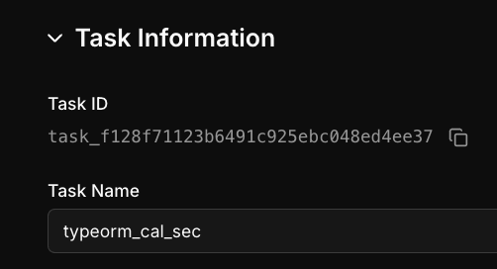

then your zip file should be named "typeorm_cal_sec.zip" or the runs will fail.

Upload the file here:

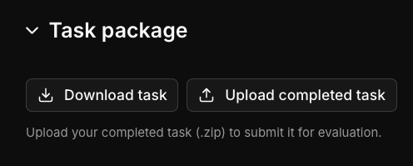

After your upload is complete (it will not take long), hit the "Run" button on the Check portion of "Harbor QA". A good run will result in you seeing this:

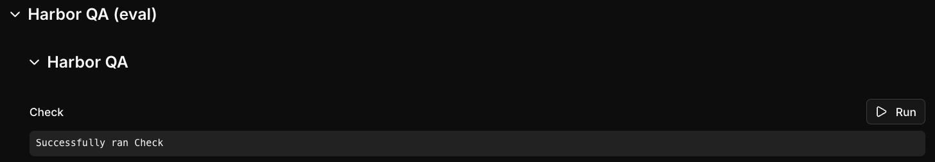

Once the Check is complete, it's time to run the Golden test by clicking its Run button. Once you have the Golden run for a given upload, you need to harvest its results and add them into your next upload, as a reference and comparison point for the analysis.

The Golden will almost always run smoothly. In the very rare occasion when it does not, ping Vachan Gupta in the #codebase-qna-helpdesk-6d2 channel in Slack.

To find the Golden harvest, hit the Run button on the next step. This will start the runs on the three frontier models in parallel - this step can take some time. Once it finishes, you'll see a new download button below:

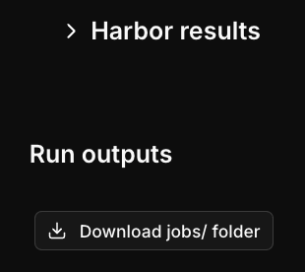

Download that folder and we'll take a peek inside. The Golden harvest will be along a file path like this - any agent/ subdirectory under golden/ that has an answer.txt and trajectory.json will do.

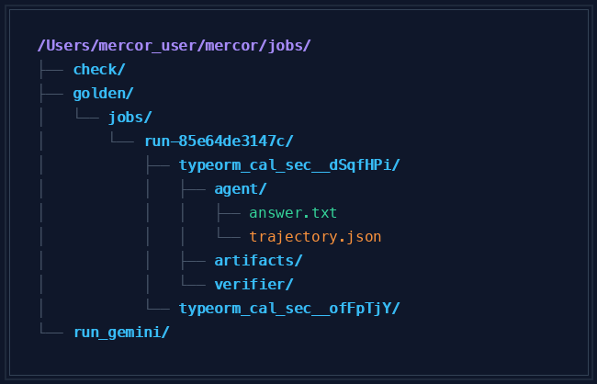

Those two files are the harvest - replace the placeholder answer.txt and trajectory.json in your uploaded zip file with those two files on your subsequent uploads. You'll need to do this Golden harvest step on every iteration as you work.

Now let's take a peek at the difficulty. The difficulty scores are contained a bit deep in the directory tree, but fortunately you don't need to inspect them manually. Here is a sample directory structure for a jobs.zip:

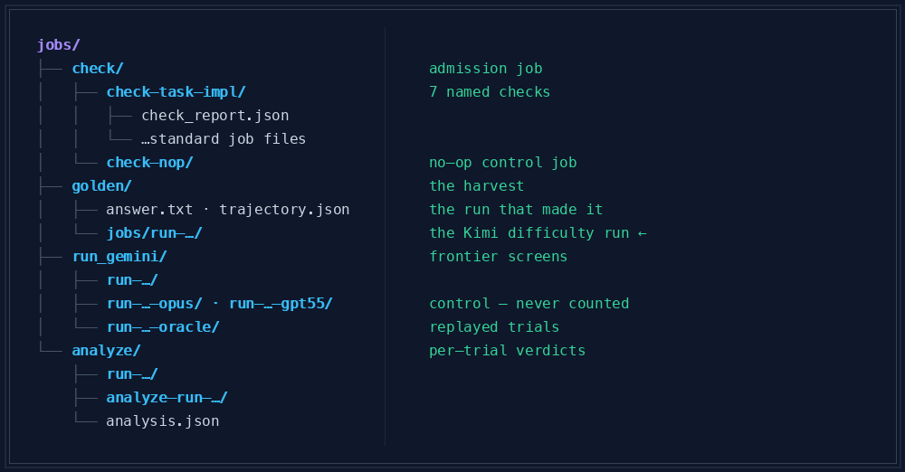

The scores live in the following files:
- Aggregates per-trial are in jobs/run/run-<model>-*/<trial>/verifier/reward.json
  - Each one contains two keys, scored from 0.0 - 1.0:
    - answer_comprehensiveness (positive rubrics)
    - negative_rubrics
- Per-criterion details are in the same folder, under reward-details.json, including each criterion's id, name, weight, score, and the judge's reasoning for the score
- Oracle scores are in run-*-oracle/ and are not included in the difficulty score; they comprise a separate gate
The gate, scored by GPT-5.5, is the acceptance model (with Kimi as a corroborating backstop). It follows the following rules:
- If the pooled reward is ≥ 0.67 (solves 2 of 3 trials), the task is too easy and is rejected
- If the pooled reward is ≤ 0.333, it is a high-difficulty task, good to keep
- Pooled rewards in between those two are borderline and are judgment calls

There are a pair of useful scripts. The first is a spot check to ensure that the task is generally passing:

difficulty.py
import json, sys
from pathlib import Path
jobs = Path(sys.argv[1])
for job in sorted((jobs / "run_gemini").iterdir()):
if not job.is_dir(): continue
if job.name.endswith("-oracle"): # own gate, not difficulty
for rj in job.glob("*/verifier/reward.json"):
r = json.loads(rj.read_text())
ok = (r["answer_comprehensiveness"] > 0.90 and r["negative_rubrics"] == 1.0)
print(job.name, "oracle", "PASS" if ok else "FAIL")
continue
scores = []
for rd in sorted(job.glob("*/verifier/reward-details.json")):
d = json.loads(rd.read_text()); tot = got = 0.0
for dim in d.values(): # both dimensions pooled
for c in dim.get("criteria", []):
w = c.get("weight", 1.0)
tot += w; got += w * (c.get("value") or 0.0)
scores.append(got / tot) # weighted credit
over = sum(s >= 0.80 for s in scores)
kimi = "-gpt55" not in job.name and "-opus" not in job.name
ok = over == 0 if kimi else over <= 1
print(job.name, [f"{s:.0%}" for s in scores], "PASS" if ok else "FAIL")

If both agents PASS, you can proceed to the more complex scoring steps. Other results may be REJECTION, BORDERLINE, or INVALID.

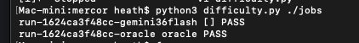

To get a detailed breakdown of the scores, use this script:

task-scores.py
#!/usr/bin/env python3
"""Per-criterion score report for a Harbor jobs folder.

Usage: task-scores.py <jobs-dir> [--csv]

Walks every verifier/reward-details.json under <jobs-dir> (any depth, so it
works on golden/, run/, oracle, and analyze layouts alike) and prints one
block per trial: the aggregate answer_comprehensiveness / negative_rubrics
scores plus every criterion's id, name, weight, and score. --csv emits one
flat row per criterion instead, for spreadsheets.

Complements difficulty3.py, which only reads the aggregate reward.json to
call the pass/fail verdict. This one is for seeing WHICH criterion dragged
a trial down, without digging through the subdirectories by hand.
"""
import csv
import glob
import json
import os
import signal
import sys

signal.signal(signal.SIGPIPE, signal.SIG_DFL)

def trial_name(details_path, root):
rel = os.path.relpath(os.path.dirname(os.path.dirname(details_path)), root)
return rel

def load_trials(root):
pattern = os.path.join(root, "**", "verifier", "reward-details.json")
for path in sorted(glob.glob(pattern, recursive=True)):
try:
data = json.load(open(path))
except (OSError, json.JSONDecodeError) as e:
print(f"!! unreadable {path}: {e}", file=sys.stderr)
continue
yield trial_name(path, root), data

def emit_text(root):
n = 0
for name, data in load_trials(root):
n += 1
print(f"\n=== {name}")
for rubric in ("answer_comprehensiveness", "negative_rubrics"):
block = data.get(rubric)
if not block:
continue
print(f" {rubric}: {block.get('score')}")
for c in block.get("criteria", []):
flag = "" if c.get("value") == 1.0 else " <-- LOST"
print(f" {c.get('id'):>4} {c.get('name'):<45}"
f" w={c.get('weight')} score={c.get('value')}"
f" ({c.get('raw')}){flag}")
if n == 0:
print(f"no verifier/reward-details.json found under {root}", file=sys.stderr)
return 1
print(f"\n{n} trial(s)")
return 0

def emit_csv(root):
w = csv.writer(sys.stdout)
w.writerow(["trial", "rubric", "id", "name", "weight", "score", "raw",
"rubric_score"])
n = 0
for name, data in load_trials(root):
for rubric in ("answer_comprehensiveness", "negative_rubrics"):
block = data.get(rubric)
if not block:
continue
for c in block.get("criteria", []):
n += 1
w.writerow([name, rubric, c.get("id"), c.get("name"),
c.get("weight"), c.get("value"), c.get("raw"),
block.get("score")])
return 0 if n else 1

def main():
args = [a for a in sys.argv[1:] if a != "--csv"]
if len(args) != 1:
print(__doc__.strip(), file=sys.stderr)
return 2
root = args[0]
if not os.path.isdir(root):
print(f"not a directory: {root}", file=sys.stderr)
return 2
return emit_csv(root) if "--csv" in sys.argv else emit_text(root)

if __name__ == "__main__":
sys.exit(main())

At this point, you have the scores that you need to determine whether or not your task needs another iteration. Review the criteria that pass and fail, adjust the Question to increase the difficulty if needed, and modify the rubrics and foils, then run through the sequence again until it is ready to submit. Whenever you see a red step, adjust and reupload a new zip file; don't continue, as further work on that uploaded zip file will not be useful.

Step | Where to look | What does green mean?
Check | jobs/check/check-*/<trial>/check report | task package parses and builds, structure is valid
Golden | jobs/golden/**/agent/answer.txt + trajectory.json | harvest exists; these two files replace the placeholders in your next upload
Oracle | run-*-oracle/<trial>/verifier/reward.json | AC > 0.90 and NR == 1.0
Difficulty runs | run-<model>-*/<trial>/verifier/reward.json | GPT-5.5 pooled ≤ 0.333
Analyze | jobs/analyze/**/analysis.json | run this last, only after everything above is green

Make sure always to use the same name for the upload, matching the Task's name, and any edits to rubrics always force a complete run, starting at the Check step.

When to Reject a Task
There are several ways that a task may be too easy or broken, or may have had a bad agent run. First, confirm that it's really the task that's the problem, not an infrastructure issue. A trial with an exception* file or no reward.json means that nothing ran. That calls for a re-run, not a rejection of the task.

Legitimate reasons to reject or to substantially modify a task include:

- The task is too easy with a leak (the instruction names the load-bearing file/function or otherwise gives the answer away). Rewrite the question to remove the leak and re-run.
- The task is too easy with no leak. Reject the task - we have a lot of tasks, and discards are inexpensive.
- The task is broken - the file structure is malformed, files are missing, contents of files are malformed. Reject the task.

QC Returned a Task - What Now?
QC returns come with a reason that will map to one of a known failure class. The most common ones include:
- question leaks
- too easy
- dead base-commit pin
- rubric-mechanism mismatch
- double-negated negatives
- bad loci
- missing judge timeout
- no runtime evidence
- hand-edited quotes
- stale oracle
- packaging/config

In general, you will fix the Task in place, just as if you were iterating in the first place, until it shows all green results. More specifically, the full process and definitions of terms can be found in the Sendbacks section.

6.1 - Task Types

6.1 Task Types
Task Type | Description
Architecture & System Design | How behavior emerges across components - routing, layers, lifecycle, and data flow. The key is finding the actual deciding component, not simply the component that appears responsible.
Root-Cause Analysis | Find the exact causal mechanism behind a bug at the pinned commit. The task should contain a plausible near-miss or wrong assumption that runtime investigation can disprove.
Code Onboarding | Understand how something actually works in an unfamiliar codebase: entry point -> execution path -> destination. It doesn't require a bug; the challenge comes from misleading names, docs, or branches.
Security | Determine where validation, authorization, sanitization, or trust decisions are actually enforced for an input path. Questions should test defensive behavior, not ask the agent to produce exploits.
API & Library Integration | Understand how the repo interacts with a third-party API/library at the pinned version, including the integration seam and differences between library behavior and what the caller assumes.

Task Structure
A Task package consists of the following components:
Task Package
├── instruction.md
│ └── Question / task instructions
├── task.toml
│ └── Task metadata and configuration
├── Rubrics
│ ├── Positive criteria
│ └── Negative criteria
├── solution/
│ ├── answer.txt
│ │ └── Golden answer
│ └── foils/
│ └── foils.toml
│ └── Plausible incorrect answers
├── trajectory.json
│ └── Golden investigation trajectory
└── environment/
└── Repository / environment setup

Evaluation Structure
The evaluation generates a jobs folder containing the evidence used to validate and analyze the Task:
jobs/
├── check/
├── golden/
├── run/
└── analyze/
- Task Package - contains the files that define and implement the Task.
- Jobs Folder - contains the evaluation evidence generated by Studio, including checks, golden runs, agent runs, and analysis.

6.1.1 - Root-cause analysis
6.1.1 Task Type - Root-Cause Analysis
What this type asks: the exact causal mechanism behind a bug symptom at the pinned commit - not the symptom restated, and not a plausible neighbor.
What makes a good one: a convincing near-miss that attracts static-only answers.
What the golden answer does: states the causal proposition plainly, cites exact lines, and reproduces cause -> effect at runtime, including why the counter-case does not trigger.
Traps to catch: accepting the Question's premise without running it; blaming the near-miss; claiming that a declared or static property drives the behavior when runtime state does. These traps are what this type's negative rubrics and foils exist to catch.
Writing the Question
- Write it in the reporter's voice, from the symptom. Keep their wrong assumption in the Question - that assumption is the trap.
- Do not quote the issue text. A verbatim quote makes the Task searchable.
- Check the pinned commit first. If the fix commit and its regression test are already in the checkout, the repo answers the Question itself, and no rubric change can save it.
What counts as runtime evidence
A probe that could have disproven the agent's own hypothesis. Reproduce the symptom, then falsify the explanation - run with the suspected setting changed and show that nothing moves. A script rigged to confirm the guess does not satisfy criterion 1.4.
Rubric shape
Positive: the actual causal mechanism (high weight); why the static reading is wrong (high weight); the file:line anchors; criterion 1.4, runtime evidence; the observable consequence, or the correct remedy if the Question asks for one.
Negative: accepts the false premise as stated; blames the near-miss subsystem; asserts that a static or declared property drives the behavior when runtime state does.
Foils: the answer that swallows the premise; the answer that rejects the premise but names the wrong mechanism; a substantively correct answer with no executed output, which must fail 1.4 and nothing else.
Too easy or broken
The symptom does not reproduce in the container; the pinned commit is after the fix; the Question named the file or the function.
Example
View example task in Studio

6.1.2 - Code Onboarding
6.1.2 Task Type - Code Onboarding
What this type asks: the day-one questions a new engineer asks a lead - where does X happen, what is the flow for Y. No bug is required.
What makes a good one: naming and layout mislead, so grep produces a confident wrong map. This is the type most often rejected as too easy, so build real depth in from the start.
What the golden answer does: gives the actual map - entry point, path, destination, with citations - and demonstrates the flow end to end at runtime.
Traps to catch: answering from a stale README or from comments; following a name that overstates its responsibility; describing the common path when the Question exercises a branch. These traps are what this type's negative rubrics and foils exist to catch.
Writing the Question
- Anchor on a discrepancy, not on orientation. "The contributing guide says the dev server picks up config changes, but mine needs a restart - what does that command actually run here?" beats "how do I run the dev server?"
- The stale README or the overstated class name is the plausible wrong answer. If the docs are accurate at the pinned commit, there is no Task here.
- Make sure the branch you are asking about is not the one the docs describe.
What counts as runtime evidence
Run the documented entry point and paste what actually happened: the resolved script chain, the process that ends up running, the file that actually gets read. Quoting the README back is the exact failure this type exists to catch.
Rubric shape
Positive: what the entry point actually does (high weight); where the documented or name-implied description diverges (high weight); the file:line anchors along the path; criterion 1.4, runtime evidence; the practical consequence for a new contributor.
Negative: restates the documentation or a comment as fact; asserts a step that does not execute at the pinned commit; answers for the common path when the Question asked about a branch.
Foils: a clean summary of the README; the right divergence with the wrong mechanism; an answer describing a newer version's behavior than the pinned commit.
Too easy or broken
The docs are accurate at the pinned commit, so there is no discrepancy to find; every criterion can be earned from a single file - move the Question deeper or drop the seed.
Example
View example task in Studio

6.1.3 - Architecture & system design

6.1.3 Task Type - Architecture & System Design
What this type asks: how behavior emerges from component interaction - routing decisions, layer boundaries, lifecycles, data flow.
What makes a good one: the deciding logic sits in a different component than the symptom points at.
What the golden answer does: names the real decision points, cites each hop of the path, and includes a runtime probe showing the interaction.
Traps to catch: blaming the wrong layer or subsystem; describing the intended architecture from docs instead of the pinned code; citing a component that looks responsible but never executes on this path. These traps are what this type's negative rubrics and foils exist to catch.
Writing the Question
- Describe what the system did, not what the components are called. "Two workers with the same config end up with different retry behavior" - not "explain how the retry resolver works".
- Leave the documented architecture standing as the plausible wrong answer. Docs and interface comments describe intent; the running system decides somewhere else.
- Ask for the path, not just the endpoint: where the decision is made, and what it overrides.
What counts as runtime evidence
The agent has to make the system resolve the behavior and then show the resolution - print the effective value after merge, log which handler was selected, or run the same operation through two entry points and show them diverge. An import graph or a call-tree dump is still static reading, not runtime evidence.
Rubric shape
Positive: the component that actually decides (high weight); the mechanism by which it wins over the documented one (high weight); the file:line anchors for the decision point; criterion 1.4, runtime evidence; the observable consequence.
Negative: attributes the behavior to the documented or naive owner; invents a config key, hook, or layer that does not exist at the pinned commit; stops at the interface without crossing into the deciding component.
Foils: the tidy answer naming the documented owner; the right component with the wrong mechanism; one hop traced correctly with no conclusion stated.
Too easy or broken
The component names give it away; one grep for a config key resolves it; a criterion names code that is dead at the pinned commit.
Example
View example task in Studio

6.1.4 - Security

6.1.4 Task Type - Security
Scope rule - read this first
These Tasks grade comprehension of the codebase's own defensive behavior. Do not write a Question whose answer is a working exploit, payload, or attack procedure, and do not target third-party systems. Probes use benign inputs and show whether a check is reached - never how to defeat it. No criterion may reward an answer for producing exploit steps. If a seed can only be answered by producing something weaponizable, do not write it: ask for a rescope in #codebase-qna-helpdesk-6d2.
What this type asks: what the code actually enforces - where validation, authorization, sanitization, or trust decisions happen for a given input path. The Question describes behavior; it never says "find the vuln in file X".
What makes a good one: enforcement looks present while the executed path says otherwise - the check fires elsewhere, later, or not at all.
What the golden answer does: identifies the real enforcement point, or its absence, and proves it with a benign probe. Evidence stays at mechanism level.
Traps to catch: asserting that a check applies because it exists; confusing validation with authorization; trusting a framework default that the pinned version does not apply. These traps are what this type's negative rubrics and foils exist to catch.
Writing the Question
- Frame it as an operator or reviewer observation: "our audit expects every write through this path to be logged, but some writes have no entry".
- The control as designed and documented is the plausible wrong answer.
What counts as runtime evidence
A benign differential probe - send a normal input through both paths and show which one reaches the check instrument the validator and show that it is not called; print the effective policy after config merge.
Rubric shape
Positive: where the control is actually enforced, or that it is not on the path in question (high weight); the condition or path that decides enforcement (high weight); the file:line anchors for both the check and the path that bypasses it; criterion 1.4, runtime evidence; the impact in the repo's own terms - for example, which writes go unlogged, or which requests reach the handler unauthorized.
Negative: asserts that the control applies everywhere because it is defined once; confuses validation with authorization; relies on a framework default that the pinned version does not apply.
Foils: the answer that trusts the control's definition; the right gap with the wrong reason; the gap identified from source alone with no probe.
Too easy or broken
The check and the path that skips it sit in the same file; the probe the answer needs cannot run in the container.
Example
View example task in Studio

6.1.5 - API & library integration

6.1.5 Task Type - API & Library Integration
What this type asks: how the repo really consumes or exposes a third-party API or library - adapter layers, version-specific behavior, compatibility flags at the pinned versions.
What makes a good one: the library's documented behavior differs from what the pinned version, or the repo's own wrapper, actually does.
What the golden answer does: locates the integration seam - the boundary where the repo's code hands off to the dependency - cites it, and runs the integration to show real behavior.
Traps to catch: quoting docs instead of pinned reality; attributing wrapper behavior to the library, or the reverse; assuming latest-version semantics. These traps are what this type's negative rubrics and foils exist to catch.
Writing the Question
- Frame it from the integration symptom: "every call through our client comes back empty even though the request succeeds - is the caller dropping it, or is the library returning something we don't handle?"
- The library's documented contract, or its docstring, is the plausible wrong answer.
- Ask for the whole picture. A one-layer answer should be incomplete by design: no single layer should be enough to earn full credit.
What counts as runtime evidence
Call the dependency as installed at the pinned version and paste the real return value, type, or exception - not the docstring, and not the changelog. Both layers need evidence: what the library actually produced, and what the caller does with it.
Rubric shape
Positive: what the dependency actually does at the pinned version (high weight); what the caller assumes (high weight); both anchors - the caller file:line and the dependency symbol; criterion 1.4, runtime evidence; that both layers are involved, or which one is authoritative.
Negative: blames the dependency version without tying it to the failing code path; repeats the documentation as the behavior; fixes one layer and never states that the other exists.
Foils: the version-blame answer; the docstring-trusting answer; the one-layer fix.
Too easy or broken
The library's own README states the difference; two answers are equally defensible depending on which layer you call authoritative - tighten the Question so that the whole picture is required
Example
https://studio.mercor.com/annotator/tasks/task_98fbc8e36c7243eb8c3cf3dc1f8e744d/?campaignId=camp_c6df75371d9a4cb09913a3fdecc10974

6.2 - Sendbacks

6.2 Sendbacks

What happens if QC returns a Task to me?
Every submitted Task goes to a reviewer. If they find a defect that is attributable to your submission, the Task comes back to you as NEEDS-EDIT rather than being approved. Their write-up should name the defect precisely: the check, the evidence (file and line, the offending value against the required one), the consequence and the fix.
A return is a normal part of the loop, not a mark against you. What matters is the turnaround: address the findings, re-validate from the top, and resubmit. (Note that per-Task pay does distinguish a one-shot submission from one that takes revisions - see the Payment section.)

What changes in Studio
- The Task moves to Needs Edits and ownership returns to you. Use Claim for Revision to pick it back up. Status can lag a few minutes behind the reviewer's action, so refresh before reporting it as stuck.
- The reviewer's findings are in the Feedback box, which is read-only for writers. If a finding is not actionable - no file, no line, no offending value - ask for specifics in Slack rather than guessing at what was meant.
- Turn revisions around promptly - within one business day where you can. (TODO: confirm the exact revision SLA and the button label in RL Studio.)
- Re-uploading clears every prior result. There is no partial re-validation. After your fix you rerun Check, Golden, Run and Analyze from the top, in that order.
- If you change the Question or a rubric, the old Golden harvest is stale. Re-harvest answer.txt and trajectory.json from a fresh reward-1.0 run before you resubmit.
`(TODO: screen shots - Needs Edits status chip, Feedback box, Claim for Revision.)

Why Tasks come back
Roughly in order of how often we see them.
Question problems
- The Question leaks the answer. It names the load-bearing file, function, constant, or mechanism, so the models one-shot it straight from the prompt and never investigate. Rewrite it to give the symptom and the evidence bar only - no file names, no mechanism, no outline of sub-questions - and update any criterion that depended on the leaked wording.
- Too easy even without a leak. The difficulty screen solves it in 2 of 3 trials, so it fails the gate. Read reward-details.json to see which criteria the model earned and from what evidence; if one grep or the README answers the Question, move it deeper - cross-module behavior, or a fact that only exists at runtime - then rerun the screen.
- The bug is already fixed at the pinned commit. It does not reproduce at base, so the Task is void. For a fix-PR Task the pin must be the parent of the fix. Re-pin (base_commit and the Dockerfile checkout SHA together, they must match exactly), or ask a lead for a re-scope if no clean pre-fix commit exists.
Rubric problems
- The rubric does not match the real mechanism. The tell is that the golden answer itself scores near 0 - fake hard, not hard. Rewrite the criteria against what the golden run actually demonstrates, then confirm with a fresh oracle.
- A negative criterion double-negates, or is phrased loosely. Correct answers flip to 0. Each 2.x carries negate = true and contains exactly one negation, naming the bad claim directly. Anything that buries a second negation ("does NOT fail to...") inverts the score on a good answer.
- Criteria cite wrong, invented, or missing file:line anchors. A criterion that names dead code at the pinned commit makes judges split on identical answers, and a criterion with no locus at all cannot be graded consistently. Open each anchor at the pin and confirm it exists and is live.
- The judge timeout is missing from the rubric toml. The judge hits the 300s cap and the whole dimension records as 0. This reads like a rubric defect and is actually configuration: confirm it from reward-details.json (raw null across the criteria rather than genuine no answers), set the timeout, and rerun before changing any wording.
Evidence problems
- No runtime evidence in the golden. The trajectory never actually ran anything, so the runtime-evidence criterion and everything anchored to it drag the score down. The golden answer must interleave the commands that were executed with their observed output - our entire project rests on the answer being unreachable by reading source alone.
- Quoted evidence was hand-edited instead of pasted verbatim. It fails the byte-match check. Re-paste every value, path and fenced block straight from the trajectory; retyping from memory is the main route by which fabricated evidence enters the dataset.
Process and packaging problems
- A rubric was edited with no fresh oracle afterwards. Any rubric change invalidates the previous controls, so a submission whose last oracle run predates the edit is an automatic bounce. Re-run the oracle to 1.0 / 1.0 before resubmitting.
- No calibration runs at all. A green oracle on its own is not a finished Task. You need at least 3 scored trials with zero exceptions; below that, the difficulty screen is uninformative and the Task is unreviewed rather than approved.
- Packaging and configuration. Individually trivial, collectively the most common bounce: the export zip stripping the exec bit off solve.sh (chmod after every export), network hosts sitting in the wrong table, a Task name over 31 characters or not in org/name format, verifier.env missing its API key line, stray files (.DS_Store, scratch scripts, stale JSON), or a double-zipped upload. Zip name must equal the Task name exactly.

Working the revision
- Read every finding before you touch anything. Fixing the first one and resubmitting costs another full round trip.
- Reproduce each finding in your own copy - open the cited line, read the cited trial - so you are fixing the defect and not the description of it.
- Fix at the lowest level that resolves it. A Question change is a rubric change; move the criteria and the foils in the same edit.
- Re-harvest the golden if anything that gets scored changed.
- Rerun the full sweep: Check, Golden, Run, Analyze. Do not run a step until the previous one is green.
- Resubmit, and note in one line per finding what you changed. The next reviewer should be able to check your work without reconstructing the history.

Before you resubmit
- Every finding is either fixed or answered with evidence.
- Oracle at its floor on both dimensions; no-op fails; every foil fails the criterion ids it declares.
- solution/answer.txt is a real harvested answer, not the HARVEST-PENDING stub, and its quotes appear verbatim in the trajectory from the same run.
- Citations hold at the pinned commit, and the pin does not already contain the fix.
- At least 3 scored trials, zero exceptions, and both difficulty gates still hold after your edits.
- Package is clean: correct file set, no extras, exec bits intact, Task name within 31 characters, zip named exactly for the Task, authored text in plain ASCII.
- All rows green in Harbor QA, then submit for review.

🔎 7 - Reviewer Workflow

⭐ 2 Reviewer workflowWhat a Reviewer Does
As a reviewer, you are the final quality gate between a completed Task and delivery. You are not authoring anything. You are deciding whether the submitted Task is sound, fair, and difficult for the right reason.
Two distinct activities are referred to as "review" on this project:
● Self-QC (audit) - the writer checking their own Task before hand-off. Covered in the Writer Workflow section.
● Review - you, checking another contributor's submission. That is the subject of this section.
The single most important reviewer skill is distinguishing a writer's mistake from a platform failure. A Task returned for a platform issue costs the writer hours of unrecoverable work, and at contributor scale that error compounds quickly. Learn the difference before you send anything back.

The three verdicts
Verdict | Meaning | Who acts next
APPROVE | Ships as-is. | Nobody. It moves to delivery.
NEEDS-EDIT | A defect is present and it is attributable to the submission. | Writer fixes and resubmits.
RERUN | Infrastructure failed. The Task may be fine. | Re-run the job. No writer action required.

NEEDS-EDIT is not a catch-all. If you cannot identify the specific line at fault, you do not have a NEEDS-EDIT yet.

What You Get
For each Task under review you should have three things:
1. The Task package - the zip, or the unzipped tasks/<slug>/ directory. This is the same shape the writer downloaded and edited: instruction.md, task.toml, the two rubric files, solution/foils/foils.toml, solution/answer.txt, the trajectory, the environment files. 14 files for a public repo, 15 or more for a private one (it also carries environment/source.tar.gz).
2. The jobs folder - in Studio, use "Download jobs/ folder" on the Task. This gives you jobs/check, jobs/golden, jobs/run, jobs/analyze and the per-trial run-* directories with their result.json. This is the evidentiary record. Every conclusion about controls and difficulty derives from it.
3. The eval results - the scored output of those runs.
If the jobs folder is missing, you can still do the static pass, but mark difficulty, controls and golden as not-assessed. Do not infer them.

The Flow
Work in this order. The sequence is deliberate: the lowest-cost checks come first because they surface most defects, and a Task that fails the static pass renders every downstream number meaningless.
1. Unpack and locate
2. Static shape
3. Read the Question and the rubrics
4. Read the controls (oracle / no-op / foils)
5. Judge difficulty
6. Check fairness (Analyze)
7. Check grounding (is the golden real)
8. Write the verdict
Read the recorded trials. Do not re-run what Studio already ran. Re-running consumes additional compute, produces a different sample, and makes your verdict impossible for the next reviewer to re-derive.

Step 1 - Unpack and locate
Work on a copy. Never alter the submitted files.
Locate by content, not by filename: the Task directory is whatever directory contains task.toml; the jobs directory is whatever tree contains check/ golden/ run/ analyze/.
If you find a zip inside the zip, that is the double-zip defect - the writer uploaded the outer wrapper instead of the Task. It presents in Studio as every row reporting "no valid task directories found". Unzip the inner archive to review, and advise the writer to upload the inner zip on future submissions.

Step 2 - Static shape
Mechanical, low-cost, and responsible for the majority of genuine rejections.
● Exactly the required files, nothing extra. No .DS_Store, no scratch files, no stray foils_job.yaml inside the Task directory.
● task.toml matches the right shape for its kind (public vs private) and contains zero TODO_ placeholders.
● Positive rubrics are 1.x ids, in order, each atomic and checkable, none carrying negate.
● Criterion 1.4 is present and verbatim. This is the fixed runtime-evidence gate and it is identical across every Task on the project. Any rewording is an automatic NEEDS-EDIT.
● Negative rubrics are 2.x, at least three of them, every single one carrying negate = true.
● Every negative states the bad claim PLAINLY. Check this explicitly; it is the most common rubric defect. A negative must read "PASS if the answer does NOT do the following: <the incorrect claim, stated directly>". If the description reads "PASS if the answer does NOT fail to..." or otherwise buries a second negation, the criterion double-negates and will fail to correct answers.
● Aggregation is all_pass on both dimensions, and both use the batched judge.
● ASCII only. Authored text must be plain ASCII. Em dashes and emoji in a seeded Task make it impossible to determine later whether an answer was AI-written, because the seed itself is already contaminated.

Step 3 - Read the Question and the rubrics
● Is it a real question? Handwritten, in a developer's voice, long enough to carry real context. Not a stub.
● Does it leak? A leaky Question hands the agent the file path, the symbol name, the mechanism, or a numbered list of sub-questions that amounts to an outline of the answer. Leak is a NEEDS-EDIT even if every number downstream looks good.
● Does it require runtime? The whole design depends on the answer being unreachable by reading source alone. If a careful static read gets it right, the Task does not belong in this dataset.
● Do the rubrics match the Question? Writers often iterate on the Question without updating the rubrics alongside it. A 1.x that asks about something the Question no longer mentions is a NEEDS-EDIT.
● Do any 2.x traps fire on a CORRECT answer? This is the highest-consequence check. If a positive criterion requires citing something a negative criterion penalizes, the golden itself cannot score 1.0, and the Task appears difficult when it is in fact defective.

Step 4 - Read the controls
Three control signals, all in the jobs folder:
oracle must score answer_comprehensiveness > 0.90 AND negative_rubrics = 1.0
no-op must FAIL
foils each at or below its expected_correctness_max,
and each expects_fail criterion actually at 0
Read them in that order and stop early when one breaks:
● Oracle errored (not scored - errored). That is infrastructure. RERUN. Nothing below it is trustworthy.
● Oracle scored 0, or below its floor. The RUBRIC is broken, almost always an over-strict 2.x firing on a correct answer. Return it for a rubric fix, not a golden fix. Do not read the difficulty numbers on a Task whose oracle has failed.
● No-op passed. The rubrics are not discriminating at all. NEEDS-EDIT.
● Foils do not fail. The foils are not discriminating. NEEDS-EDIT.

Step 5 - Judge difficulty
Difficulty is set by the frontier model screen, over 5 trials. BOTH gates must hold for the Task to be tagged HARD:
Gate A answer_comprehensiveness mean <= 0.4
OR negative_rubrics mean <= 0.4
(both columns at 0.67 or above means the Task is too easy)

Gate B per trial, pooled weighted credit
= sum(weight * value) / sum(weight), across BOTH dimensions.
EVERY trial must come in under 80%.
Any single trial at 80% or above caps the Task at MEDIUM,
no matter what Gate A says.
Gate B is the safeguard against artificial difficulty. Without it, a Task can appear difficult because one narrow negative (typically the quote-fidelity criterion firing on formatting) depressed the negative-rubrics mean, while the model in fact solved the substance in every trial. Such a Task is a MEDIUM at best.
Per repository the target is 2 HARD + 1 MEDIUM. A Task the frontier model solved is a MEDIUM candidate, and whether it ships depends on whether that repo's medium slot is still open. That is a cross-Task call - flag it to the lead rather than deciding alone.
Standing caveat: difficulty requires 3 SCORED trials and zero exceptions. With fewer than 3 scored trials, or any exception in the run, the screen is uninformative. That is a RERUN, not a result. Do not average partial trials and record the outcome as a verdict.

Step 6 - Check fairness
The Analyze step exists to confirm the failures were the failures the Task predicted - that the agents failed for the reason the Task's declared failure model predicts, and not because the environment failed. Read the per-trial fairness verdict on the failing trials, not the analyzer's overall mean.

Step 7 - Check grounding
● Is the golden real? solution/answer.txt must not still be the HARVEST-PENDING stub. A Task cannot be delivered on a placeholder golden. (A Task still in authoring is allowed to be pending - a Task in front of you for delivery review is not.)
● Is it in lockstep? Every value, path and fenced code block the golden answer quotes should appear verbatim somewhere in the trajectory - pasted from the run, not retyped from memory. Retyped quotations are the primary route by which fabricated evidence enters the dataset.
● Is it grounded at the pinned commit? Line numbers and snippets must correspond to the real repository at the pinned commit, not at HEAD.
● Is the pin clean? If the pinned commit already contains the fix, the Task is contaminated. For a fix-PR Task the pin must be the PARENT of the fix.
● Any secrets? Scan the answer, the trajectory and the artifacts for keys, tokens and credentials. This is a hard stop.

Step 8 - Write the verdict
One verdict, plus one clear line per issue. For a NEEDS-EDIT, state exactly what to change and why. A note such as "rubrics need work" costs a full round trip and gives the writer nothing actionable; "criterion 2.2 double-negates (negative_rubrics.toml line 41) - restate the bad claim plainly, it currently zeroes correct answers" is one edit and done.

AutoQC
AutoQC is the automated pass that runs over a submission before you read it. It is an LLM judge plus a set of deterministic checks, and it produces a findings report against the Task package, the jobs proofs, and the metadata.
AutoQC is visibility, not a hard gate. It does not approve or reject anything. It tells you where to look. The verdict is always yours.

What it looks for
Findings come back in four buckets, each with a severity:
blocker the Task will be dropped, hard-fail, or be pulled from delivery
major the Task will grade wrongly or unfairly
minor polish
info visibility only, usually a known platform behavior
Bucket | What it checks
Project rules / task.toml | Name format, schema version, the artifacts list, verifier environment keys, network configuration, the rewardkit pin, metadata completeness, no TODO_ tokens, pinned commit is a real 40-character SHA.
Structure | The exact file count and set, no stray or double-zipped files, script permissions, the golden prompt still carrying its instruction token, the golden answer not being the HARVEST-PENDING stub, the final answer wrapped in exactly two marker lines.
Question / rubric / golden | Question is real, handwritten and non-leaky; requires runtime; both dimensions configured correctly; ids dotted and in order; 1.4 unmodified; every 2.x negated and plainly worded; the golden's quotes appearing verbatim in the trajectory; citations valid at the pinned commit.
Difficulty and fairness | The frontier-model screen against both gates, contamination, the oracle floor, the no-op failing, foils discriminating, at least three scored calibration trials existing, and a secrets scan.

Every finding it emits should carry the file and line, the offending value against the required one, and the one-line consequence. A finding without those elements is not actionable; treat it as a pointer and verify it yourself.

What to send back
Return to the writer (NEEDS-EDIT) when the defect originates in an authoring decision:
● The Question leaks the answer or the method.
● The Task is too easy - it fails the difficulty gates.
● answer.txt is still HARVEST-PENDING on a finished Task.
● The oracle scored 0 because a rubric is over-strict or double-negated.
● Foils do not fail, or an expects_fail id does not exist.
● A contract violation in task.toml - wrong shape for public vs private, leftover TODO_, missing or reworded 1.4, a 2.x missing negate = true.
● An off-list repository.
● Post-fix contamination - the pinned commit contains the fix.
● Non-ASCII characters in authored text.

What NOT to send back
These are platform failures. The correct response is RERUN, or in some cases disregarding the row. Returning them to the writer is the costliest error a reviewer can make.
● AgentTimeoutError on every trial - the repository is too large for the step or time budget. Not attributable to the writer.
● error_max_structured_output_retries - a transient judge-side failure. The trial is unscored, not failed. Do not count it as a failure in the difficulty calculation.
● API rate-limit errors on Analyze - transient. Wait, then re-run.
● Analyze returning all not_applicable - two possible causes, and they are opposite. If the trial artifacts exist and are substantive, it is a payload-assembly issue: disregard that trial. If analyzer cost is near zero, the trial produced nothing at source, the difficulty screen is invalid, and the whole run needs a RERUN.
● Golden reporting no candidates while a trial actually scored 1.0 - a known collector issue. Confirm the Task has its reward configuration and the correct rewardkit pin; if it does, the harvest is valid and the failing row can be disregarded.
● Every row saying "no valid task directories" - almost always a double-zipped upload (review the inner zip) or a task.toml the discoverer rejects. Check the Task name format first.
● Quote-fidelity failing with a sandbox or permissions message - the checker's scratch directory was blocked. This is not a misquotation in the answer. Do not ask the writer to rewrite it.
● Missing verifier credentials producing "not logged in" style errors - an environment problem, unless the Task itself omitted the keys from its verifier configuration. Check the configuration before deciding which applies.
● Alarming stdout in the agent logs - strings such as "error" or "Tool call error" are frequently template text rather than a crash. Read the surrounding lines before acting.
As a discipline: for every finding you are about to write up, name the platform cause you ruled out. If you cannot name one, the check is not complete.

Grading Spec
This is how a finding becomes a verdict, and what your written review must contain.

Severity to verdict
Highest severity present | Verdict
Nothing, or info only | APPROVE
minor only, all mechanical (a stray file, a metadata field, a criterion-naming issue) | APPROVE with the fix list attached
Any major | NEEDS-EDIT - the writer can clear it in one pass
Any blocker | NEEDS-EDIT - and if the Question or the source issue itself is the problem, escalate to the lead rather than returning it to the writer
The deciding evidence is an infrastructure failure | RERUN - no writer action

Break ties toward the lower severity. If you are unsure whether something grades wrongly or is merely untidy, it is minor.

Hard blockers (a Task cannot be delivered with any of these)
● answer.txt still HARVEST-PENDING.
● Oracle not at its floor on both dimensions, or fewer than 3 scored calibration trials in existence. A Task approved with zero trials is not approved, it is unreviewed.
● Secrets or credentials anywhere in the answer, the trajectory or the artifacts.
● The golden's quoted evidence not appearing verbatim in the trajectory.
● Citations that do not hold at the pinned commit.
● A leaky Question.

What your written review must contain
For each finding: the check, the evidence (file and line, plus the offending value against the required one), the consequence in one line, and the fix. Plus the platform cause you considered and ruled out.
For difficulty: state which gate decided it and cite the numbers. "Gate B - trial 2 pooled weighted credit 0.91, caps at MEDIUM" is re-derivable by the next person. "Seems too easy" is not.
Quote real judge reasoning and real trial evidence. Never paraphrase them. The standard is that another reviewer, reading only your write-up, can reach the same verdict without reopening the jobs folder.

💳 8 - Payment info

💵 9 Additional Info9.1 Payment
Mercor pays out weekly. Payouts run on Wednesdays through Stripe (primary) or Wise (fallback) for the previous pay period.
Role | Pay Model | Rate
Writer | Per task | $130 (one-shot) / $120 (1–2 revisions)
Pay is delivered as task bonuses.

9.2 Time Tracking
This is a mixed project, so Insightful is required for everyone on it. Writers are paid per task but still run the Insightful desktop app for activity and calibration. Track your time regardless of your role.

9.3 Referrals
You can refer other experts to Mercor and earn referral rewards from the Referrals tab in your Mercor profile.

9.4 Social Media and Confidentiality
Client and project work is confidential under the CIIAA. Do not post about client work on social media, and remember you are an independent contractor, not a Mercor employee.

9.5 Taxes
You complete the appropriate tax form during onboarding: a W-9 if you are a US person, or a W-8BEN if you are not.

9.6 AI & External Tool Usage Policy
Do not ask an LLM to rewrite your responses, to evaluate or grade the candidate patch, to write your justifications, or to predict code behaviour or runtime results.
On this project, LLMs may only be used to explore the repos. Because this is a human-data project, any LLM usage detected in the evaluation, grading, or justification process will result in offboarding.

